Coronavirus: The disease

Coronavirus disease (COVID-19) is an infectious disease caused by a newly discovered coronavirus. Coronaviruses are a large family of viruses, some of which cause illness in people, and others that circulate among mammals and birds. COVID-19 was first identified in Wuhan City, Hubei Province, China, in December 2019. Since then it has spread to many countries around the world, with the World Health Organization declaring it a pandemic. The case fatality rate is approximately 2.3% (based on initial information).

Symptoms

Most people infected with the COVID-19 virus will experience mild to moderate respiratory illness and recover without requiring special treatment.  Older people, and those with underlying medical problems like cardiovascular disease, diabetes, chronic respiratory disease, and cancer are more likely to develop serious illness. It affects different people in different ways. Most infected people will develop mild to moderate illness and recover without hospitalization.

Most common symptoms:

* Fever.
* Dry cough.
* Tiredness.

Less common symptoms:

* Aches and pains.
* Sore throat.
* Diarrhoea.
* Conjunctivitis.
* Headache.
* Loss of taste or smell.
* A rash on skin, or discolouration of fingers or toes.

Serious symptoms:

* Difficulty breathing or shortness of breath.
* Chest pain or pressure.
* Loss of speech or movement.

Transmission

The COVID-19 virus spreads primarily through droplets of saliva or discharge from the nose when an infected person coughs or sneezes, so it’s important that everyone practices respiratory etiquette (for example, by coughing into a flexed elbow).

Treatment and prevention

At this time, there are no specific vaccines or treatments for COVID-19. However, there are many ongoing clinical trials evaluating potential treatments. On average it takes 5–6 days from when someone is infected with the virus for symptoms to show, however it can take up to 14 days. The best way to prevent and slow down transmission is be well informed about the COVID-19 virus, the disease it causes and how it spreads.

To prevent infection and to slow transmission of COVID-19, do the following:

* Wash your hands regularly with soap and water, or clean them with alcohol-based hand rub.
* Maintain at least 1 metre distance between you and people coughing or sneezing.
* Avoid touching your face.
* Cover your mouth and nose when coughing or sneezing.
* Stay home if you feel unwell.
* Refrain from smoking and other activities that weaken the lungs.
* Practice physical distancing by avoiding unnecessary travel and staying away from large groups of people.

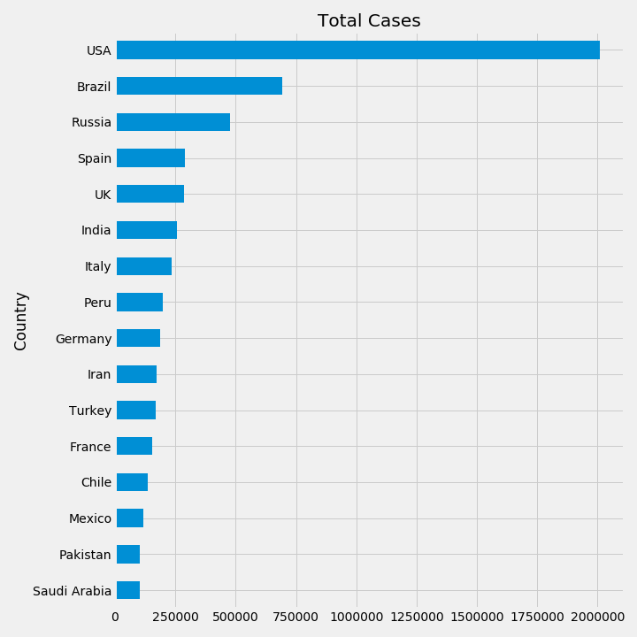The graphs that were plotted as of 8th June, 2020 are:

Total Deaths: countries with highest number of deaths due to Coronavirus recorded, arranged from greatest to lowest number of deaths.

Total Cases: countries with highest number of Coronavirus cases recorded, arranged from greatest to lowest number of total patients.

*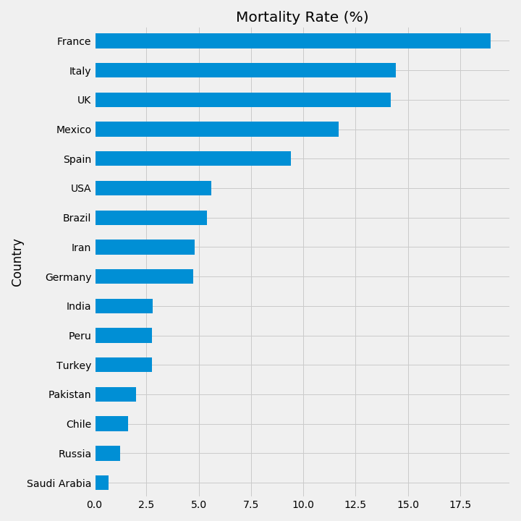*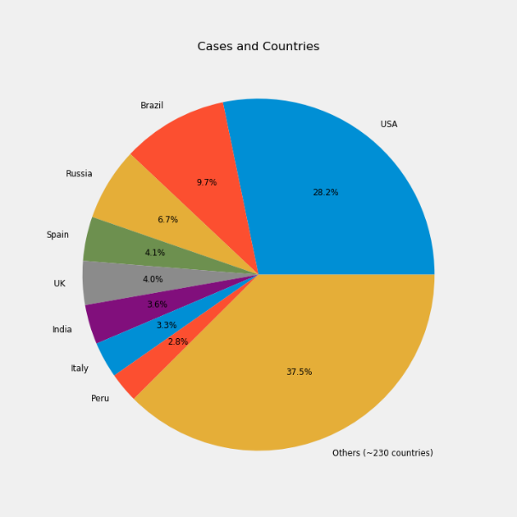

Mortality Rate (%): Countries with highest mortality rate of Coronavirus patients, arranged from greatest to lowest.

Total Cases: Percentage of total cases that every major country is contributing.